1. Create a package named "com.example.hr" that includes an Employee class. The

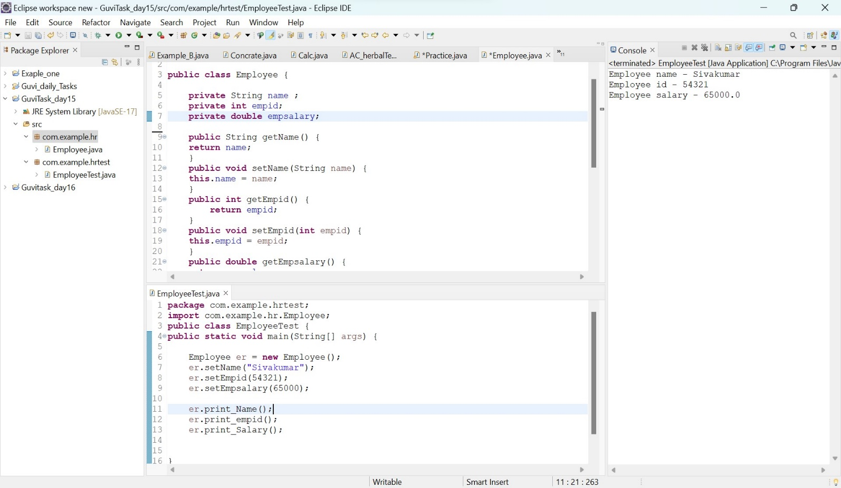 Employee class should have the following fields:

1. 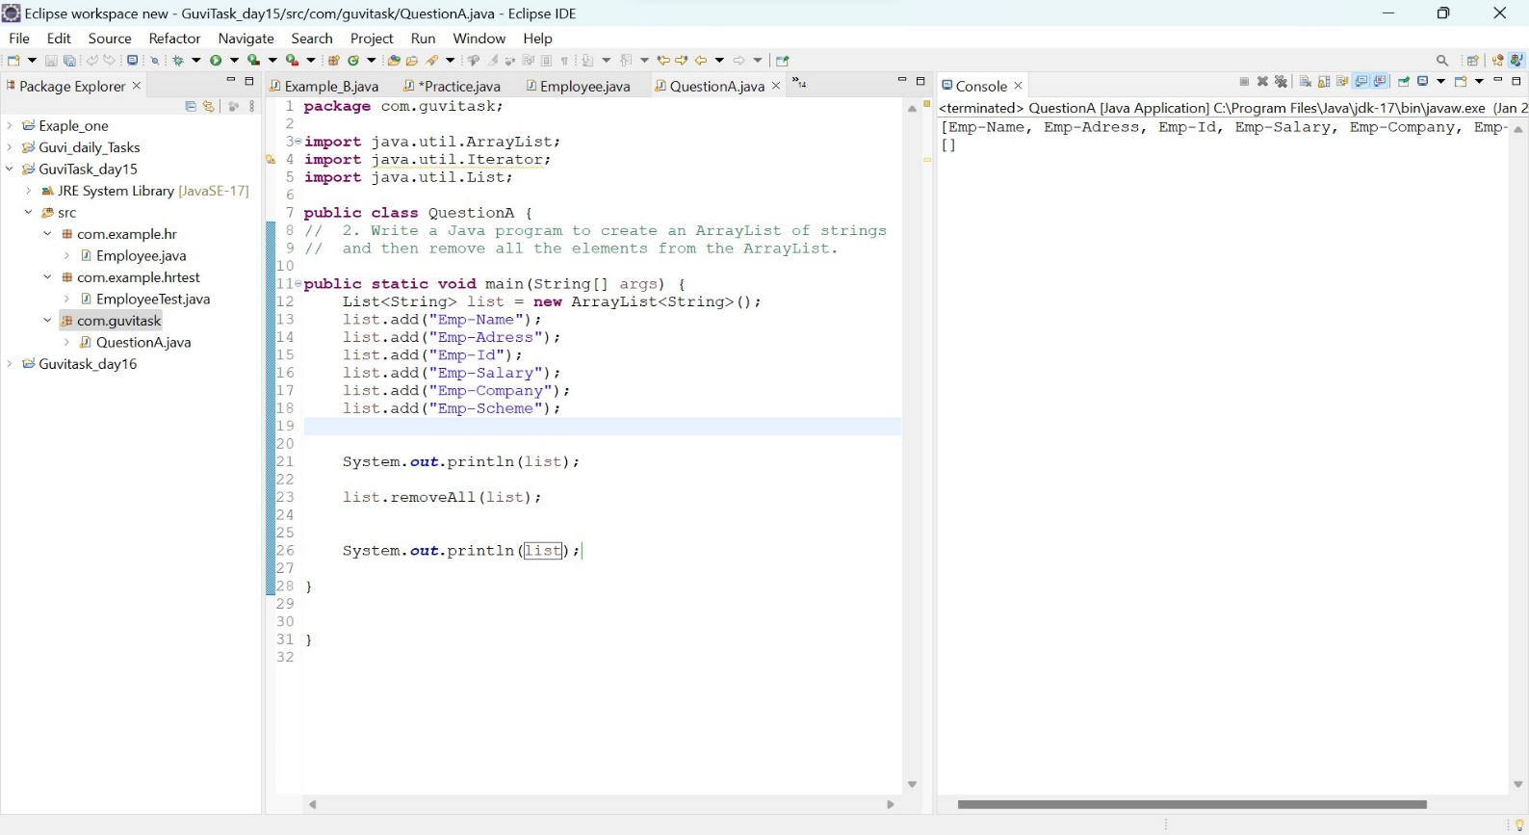Write a Java program to create an ArrayList of strings and then remove all the elements from the ArrayList.

3. Write a Java program to create a TreeMap of employee IDs and names. Then, print out the names of all the employees in alphabetical order.

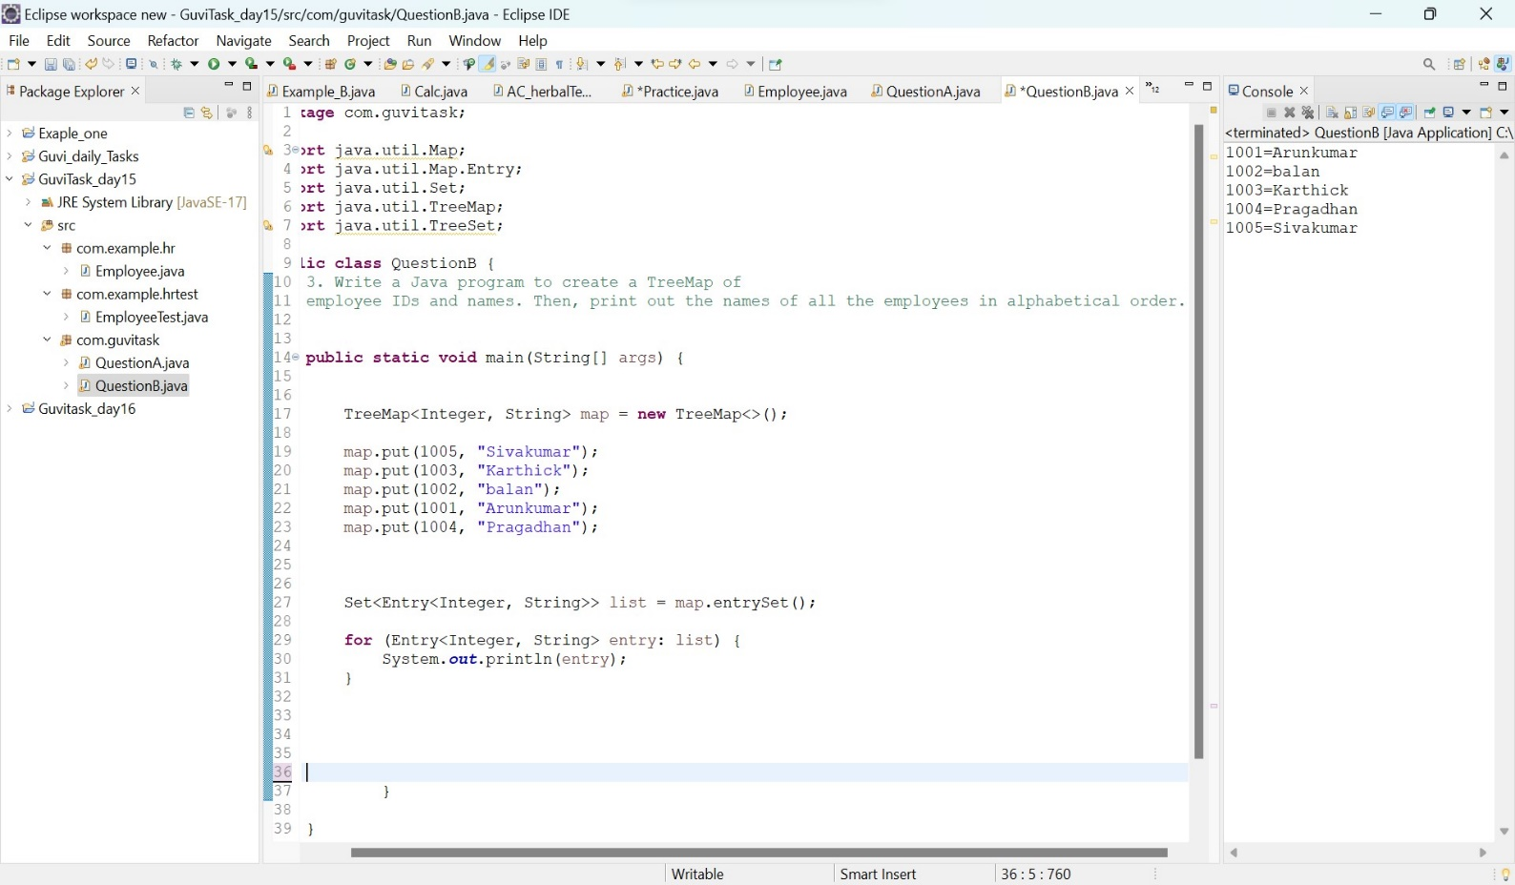

1. 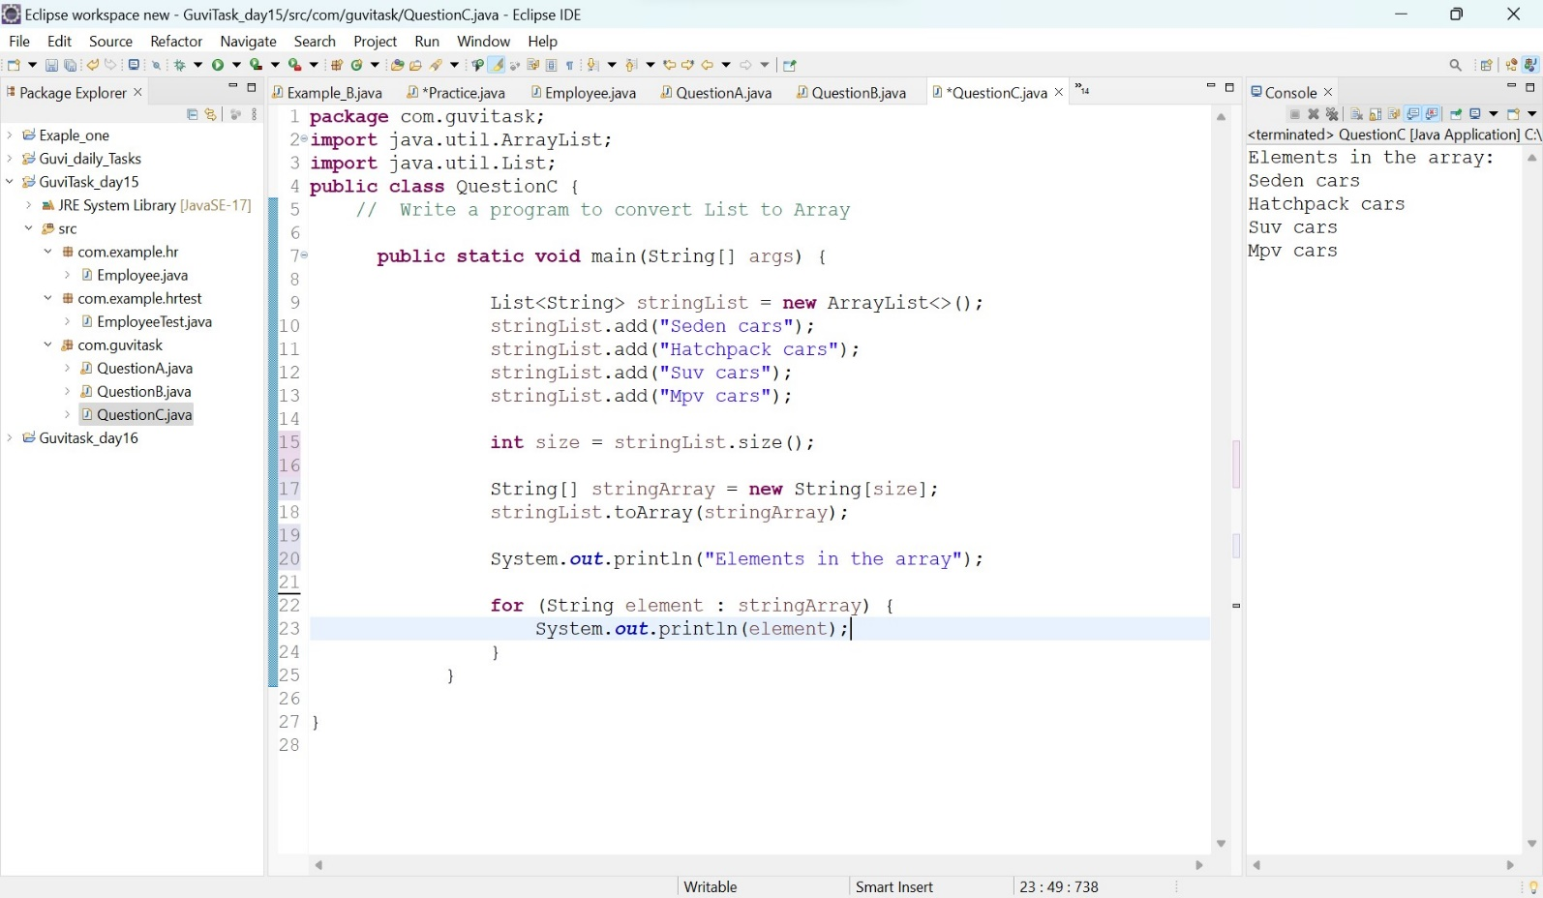Write a program to convert List to Array